Upload to S3 Bucket
For this exercise, download and upzip log_data from the Resources tab in the classroom.
- Click on the bucket you just created and select Upload on the top left.

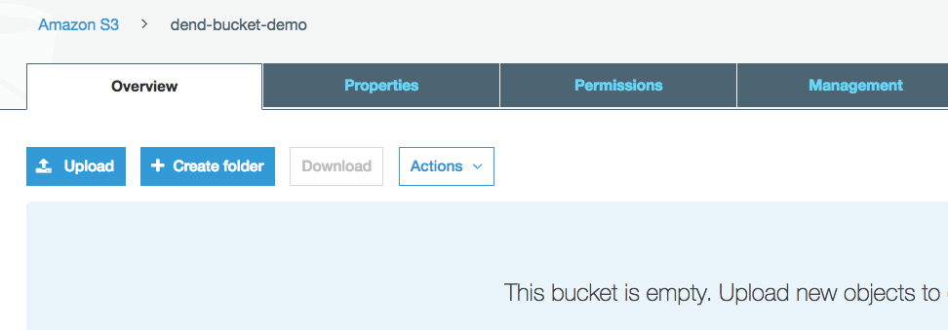

- Select Add files and choose the log_data.csv file you downloaded from this classroom.

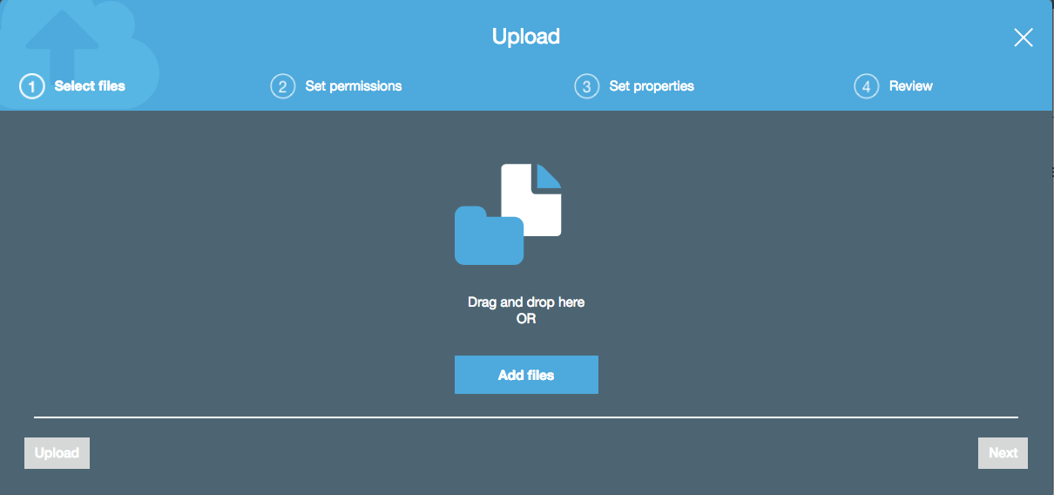

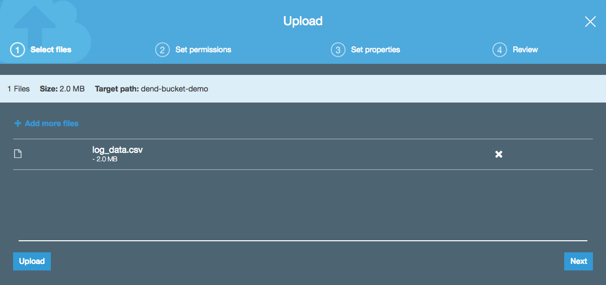

- Leave the default settings and select Next.

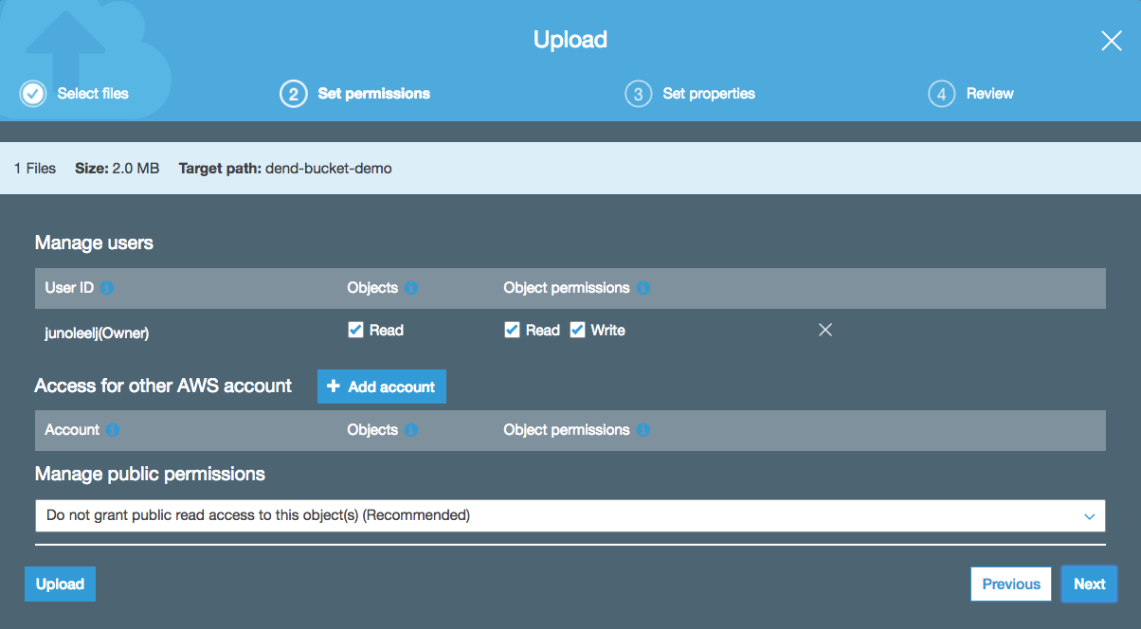

- Choose the Standard storage class and select Next.

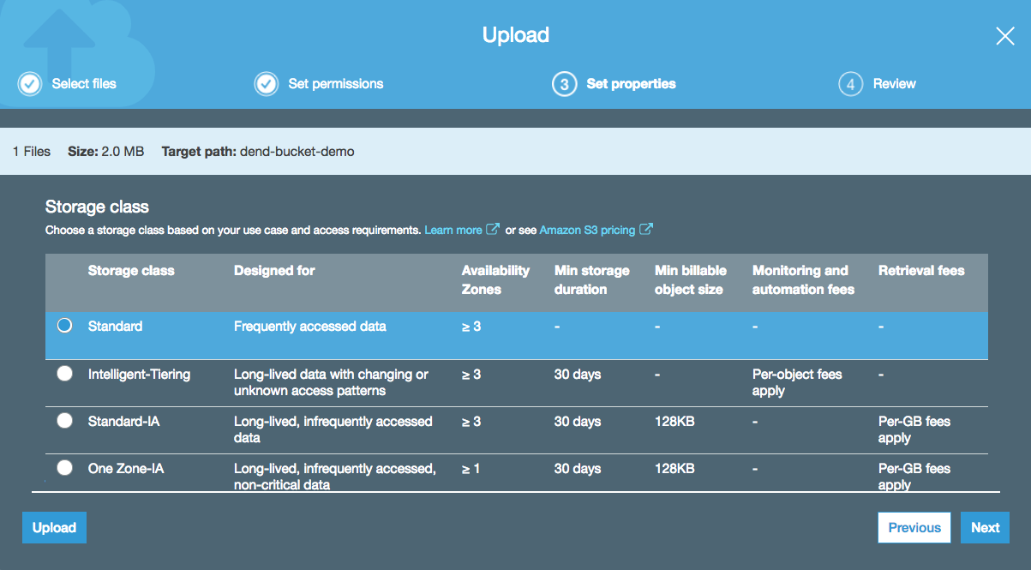

- Review your settings and select Upload.

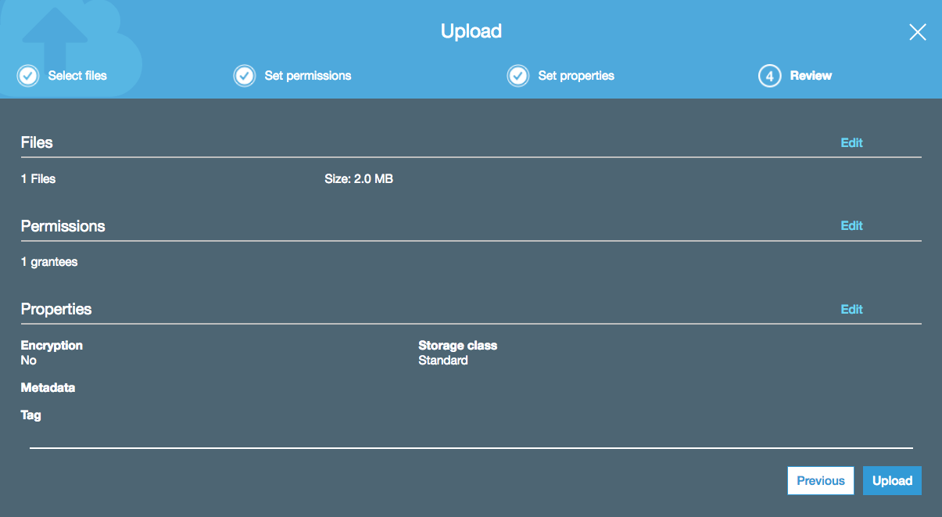

- You should be able to see details on the file you just uploaded by selecting it in your bucket.

